Mae Fah Luang University
หมู่ที่ 1 333, Tha Sut, Mueang,
Chiang Rai 57100, Thailand



1501413 : Big Data Management & Analytics

Mini Project Report

------------ Title ----------
Customer Segmentation for E-Commerce using k-Means Clustering

Student ID: 6531501208 Student NAME: Sai Hae Naing Lay
Student ID: 6531501202 Student NAME: Aung Ko Hein
Student ID: 6531501237 Student NAME: Zwe Lulin Maung

Under the guidance of

Dr. Prof. Shanmugam Nandagopalan


School of Applied Digital Technology

Objectives
To segment customers based on their purchasing behavior using Recency, Frequency, and Monetary (RFM) features and apply K-Means Clustering to group similar customers for targeted marketing strategies.

1. Data Loading and Cleaning
- Source: data.csv
- Encoding: ISO-8859-1
- Cleaning Steps:
  - Dropped rows with missing CustomerID or Description.
  - Filtered only positive values for Quantity and UnitPrice.
  - Converted InvoiceDate to datetime format.
  - Created a new feature TotalAmount = Quantity × UnitPrice.

2. RFM Feature Engineering
- Reference Date: One day after the latest InvoiceDate in the dataset.
- RFM Metrics:
  - Recency: Days since the customer's most recent purchase.
  - Frequency: Number of unique invoices (transactions).
  - Monetary: Total amount spent.
These metrics were grouped by CustomerID to profile each customer.

3. Feature Scaling
- Tool Used: StandardScaler from sklearn
- Reason: To normalize the RFM features so that each contributes equally to distance calculations in clustering.

4. Finding Optimal Number of Clusters (k)
- Method Used: Elbow Method
- Metric: SSE (Sum of Squared Errors/Inertia)
- Range Tested: 1 to 10 clusters
- Observation: A bend (elbow) around k=4, suggesting 4 is the optimal number of clusters.

5. K-Means Clustering
- Chosen k: 4
- Model: KMeans with random_state=42 for reproducibility
- Assignment: Each customer was assigned to one of the 4 clusters.

6. Cluster Analysis
Summary Table:
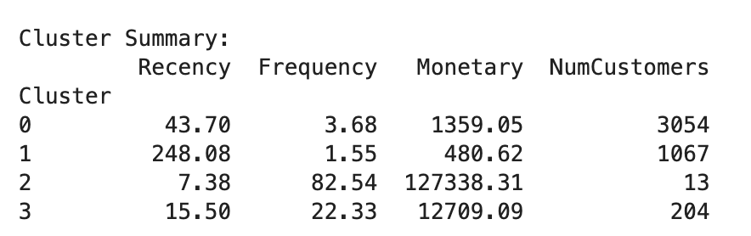
Interpretation Tips:
- Lower Recency = More recent customers.
- Higher Frequency and Monetary = More valuable and loyal customers.
- This analysis helps in understanding customer segments like:
  - Loyal customers
  - High spenders
  - At-risk customers
  - New customers

7. Visualization
- Tool Used: Seaborn PairPlot
- Dimensions: Recency, Frequency, and Monetary
- Colored by: Cluster
- Purpose: To visually explore the separation and distribution of customers across clusters.
Complete Code / Program
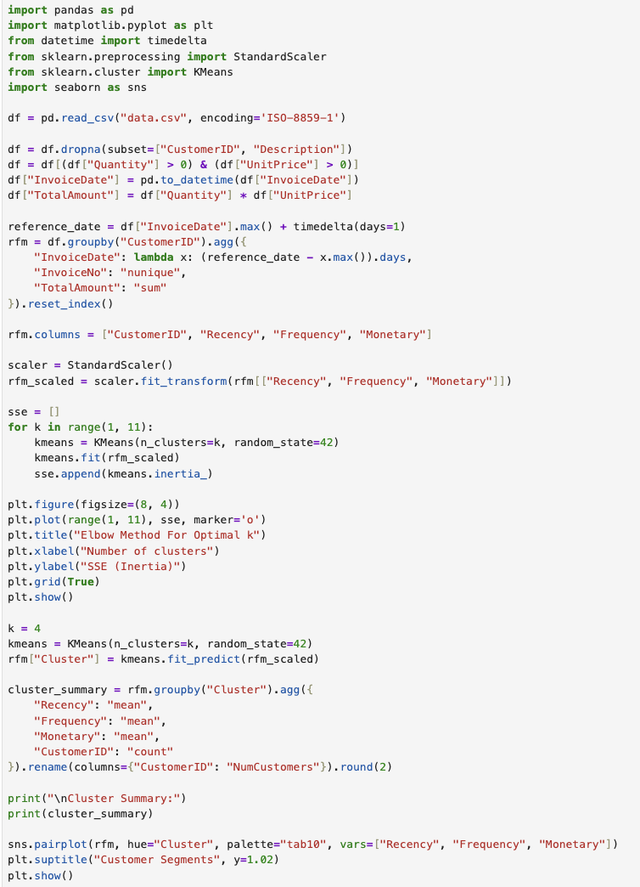
Result
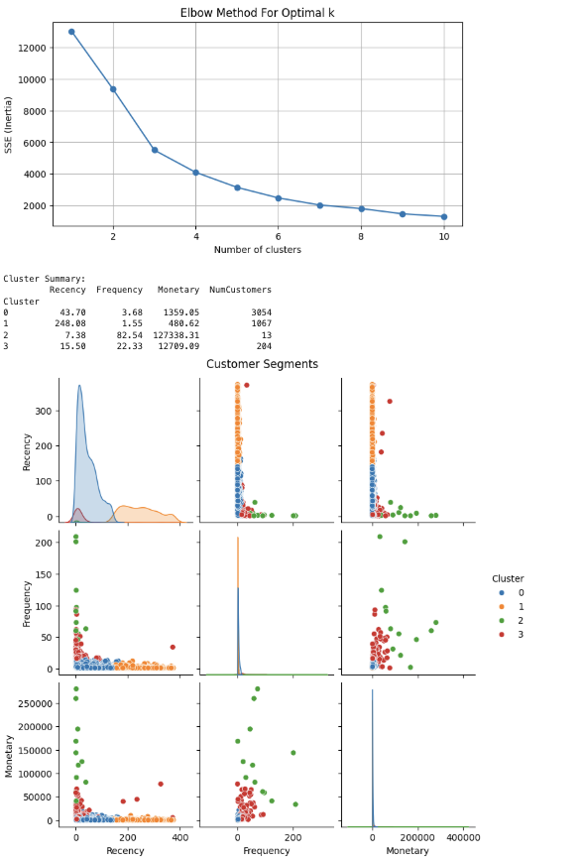

Conclusion
This project successfully performed customer segmentation using the RFM model and k-means clustering. The insights derived from the cluster profiles can help businesses:
- Tailor marketing strategies
- Prioritize high-value customers
- Re-engage inactive customers
- Optimize customer service efforts

Reference
https://www.kaggle.com/datasets/carrie1/ecommerce-data?resource=download

